**IP Address**

* IP Address is used to uniquely identify the device
* Execute ipconfig  
  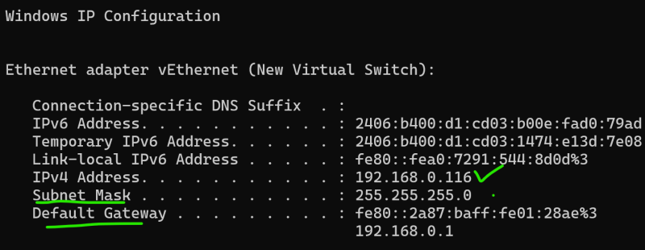
* IP Address = Network id + host id
* IP format which are looking at is IPV4 X.X.X.X which is a 32 bit number represented as 4 octets
* Range of IPv4 0.0.0.0 to 255.255.255.255

**How to find out Network id and Host id**

* SM has two possible values 0 or 255 (my representation is decimal)
* Find out Network id and Host id

1 2 3 4

IP: 192.168.0.116

SM: 255.255.255.0

Octects with 255 as SM

1,2,3

Network id: 192.168.0

host id: 116

**Private Networks-** There are three ip ranges reserved for private networking

192.168.0.0 to 192.168.255.255

172.16.0.0 to 172.31.255.255

10.0.0.0 to 10.255.255.255

**Router**

* Router is a device which can forward packets from one network to another
* Default Gateway in ipconfig reprsents your router.
* NAT (Network Address Translation) : This server establishes internet connectivity for private networks as it does Address Translations.